20.48: For a monatomic ideal gas, 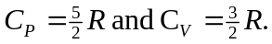
a) ab: The temperature changes by the same factor as the volume, and so
The work 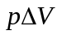is the same except for the factor of 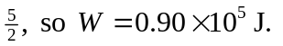
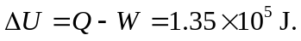

bc: The temperature now changes in proportion to the pressure change, and and the work is zero

ca: The easiest way to do this is to find the work done first; W will be the negative of area in the p-V plane bounded by the line representing the process ca and the verticals from points a and c. The area of this trapezoid is 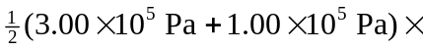 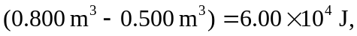and so the work is 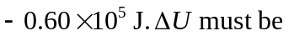 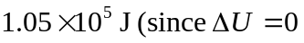 for the cycle, anticipating part (b)), and so Q must be 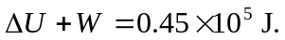
b) See above; 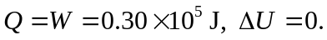
c) The heat added, during process ab and ca, is 2.25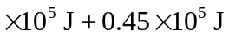 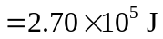 and the efficiency is 